Dynamic AI based Email Voice Assistant for Web Services

Anandasayanam K  
*UG scholar , Department of IT,*  
*Saveetha Engineering college,*Chennai, Tamil Nadu  
anandasayanamkumar[@gmail.com](mailto:keerthivasan.ravi14@gmail.com) G NaliniPriya  
*Professor , Department of IT ,*  
*Saveetha Engineering college,*Chennai, Tamil Nadu  
dr.g.[nalinipriya@](mailto:nalinipriya@)gmail.com

Hariram B  
*UG scholar , Department of IT,  
Saveetha Engineering college,*Chennai, Tamil Nadu  
[hariram26072@gmail.com](mailto:hariram26072@gmail.com)

Maheswara Pandian G  
*UG scholar, Department of IT,*  
*Saveetha Engineering college,*Chennai, Tamil Nadu  
[mahes.gpandian@gmail.com](mailto:mahes.gpandian@gmail.com)

*Abstract— In recent years, voice assistant has shown significant process and its potential is growing. And billions of devices that incorporates them in domestic nowadays. Then, to communicate with one another, Email is one of the most prevalent way. In this paper, we are targeting to establish an AI based email voice assistant system. The voice assistant listens to the user's voice input and converts it as a text and then sends it as an email message to the recipient. Firstly, we have to provide user’s email id and its Gmail account’s password to authenticate and this can be executed using Python in PyCharm community IDE. SMTP is the most common and popular protocol of email which means Simple Mail Transfer Protocol . It is used for transmitting email from one account to other over the internet. Protocol means a list of instructions that validate and manage the transfer of email and also it pushes the message from client to the server. MTA ( Message Transfer Agents ) is the client which should be present in the system to send and receive mail.*

Keywords— Speech To Text, Speech Recognition, Voice Mail Assistant, Technical Bots, Artificial Intelligence.

# I. Introduction

Voice assistant involves whenever computers have conversations with humans . Appropriate responses are being determined by system and they working hard behind it to interpret what is being said. And they respond in such a way that human can understand easily. It promotes the development of technology for future trends. The application of voice assistant is that it can analyse user’s voice and can give feedback appropriate to it. It can provide 24*7 technical support and engaging user experience. We can speak to the voice assistant as a normal person and it can respond to appropriate questions that we asks. A server which runs on a computer, listening for requests at a particular port over WWW (World Wide Web) is called a web server. The implementation of email voice assistant requires SMTP library, and the packages which contains speech recognition, Pyaudio, pyttsx3 and microphone.

# II. Related works

We had gone through many literature papers that used email voice assistant and certain literature paper were found related to the concept. Harsh D Shah [1] et al. proposed a method in which user can send messages to the recipient where receiver’s email id is already programmed in the sender’s record. This paper is based on Automated Speech Recognition method. By using this method, a user can access their own account, with voice instruction.

Another paper by Sunny Kumar [2] et al. proposed a system in which a new email architecture system was created that can be needful to blind people to use the model for email purposes without any earlier execution. Suresh Malodia [3] et al. inspects the different consumption principles corelated with the use of voice instruction. Mixed method approach were undertaken by “Theory of consumption values” (TCU).

In Another paper S . Subhash [4] et al. suggested a voice assistant can collect the speech from the mic and then changes it to wording. Then, that text can be sent via Google text-to-speech . The text is converted into audio file which is an English language, by GTTS engine. Finally, Python package plays the speech received from GTTS. Sherly Noel [5] proposed a system to describe an algorithm which changes text-to-speech for looking through emails and also changes speech-to-text for composing an email. In this algorithm, for speech recognition, Application Programming Interface is applied. Tae - Kook Kim [6] suggests an Artificial Intelligence (AI) based voice command assistant . In this model Application Programming Interface service, Google assistant and auto-execution system were designed. Georgios Germanos [7] et al. presented the location of individual data and types inside the environs of three famous assistants.

Dengke Tang [8] et al. proposed three pattern mechanism under complete learning configuration. And they are (i) ResNet, (ii) Convolutional Neural Network (iii) Recurrent Neural Network + Convolutional Neural Network. Further, they also looked over various data enhancement, stabilize and illustrating methods, for improving performance of system. Saadman Shahid Chowdary [9] et al. proposed the methods for developing a voice manipulated International Phonetic Alphabet, which can approach immediate instruction in two dialects: Bengali and English, to execute boring task for user. Prince Bose [10] et al. proposed the voice directed system for the unsighted person and visually challenged was formulated which receives data in the mode of audio . It allows the user for sending and receiving mails, authorizing everyday news, setting alarms and making notes. Patrik Emanuel Mezo [11] et al. proposes a new architecture mail outline by integrating investigation activities on peer-to-peer structure development and methods of resource estimation in the network peer.

# III. System architecture

The entire purpose of the SMTP (Simple Mail Transfer protocol) is to permit software to transmit emails over the internet by a set of communication guidelines . The authenticate is used to check whether the given information are correct or not. Figure 1 explains proposed system architecture for email voice assistant.

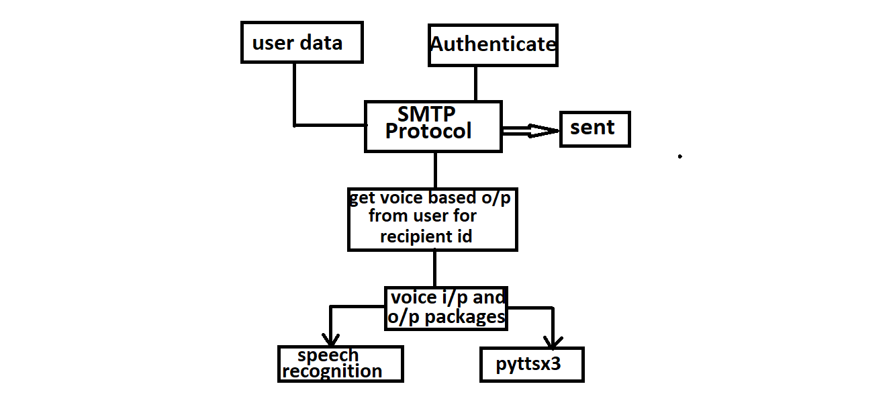

Fig. 1. Proposed system architecture for email voice assistant.

The voice input output packages is responsible for getting voice input and then analyse the input and give appropriate feedback to the user.

## A. Proposed Algorithm

The new developed technique shows an edge over the existing system by allowing users (sender) to send messages to another user (receiver) through voice assistant.

The sender’s option is not restricted to one particular recipient also more recipients can be added in the surrounding code space. Figure 2 Explains proposed Voice Assistant algorithm.

EMAIL VOICE ASSISTANT ALGORITHM:

|  |
| --- |
| **Input:** User voice input  **Output:** Message sent by assistant  **Step1**: Start  **Step2:** If new user , login using email & password  **Step3:** Get voice input about the recipient, subject, body of the mail.  **Step4:** Send message  **Step5:** If [yes in send more : ] , go to step 3 or  Else  go to step 6  **Step6:** Stop |

Fig. 2**.** Proposed Email voice assistant system algorithm

## B. User Data

The user's data means the data that the user sets up or possess. The user (sender) can send email to another user (recipient) only when he provide his email id and its own account password. He have to provide recipient list with their email id.

## C. Authentication

Authentication is the method of confirming the recognition of user. After the user provides his data, his data is authenticated to check whether the given information are correct or not. Then, he have to disable “less secure app access” in Gmail settings. Then only, the email assistant has access to the user’s Gmail account.

## D. SMTP Protocol

## The user has to import smtplib. Software is allowed to send emails over the internet with the use of SMTP (Simple Mail Transfer protocol) which is a protocol or a set of communication guidelines. On port number 587 (for encoded message) and 25 (for plain message), Transmission Control Protocol (TCP) is used by the servers of Simple Mail Transfer Protocol (SMTP).

## E. Voice I/P O/P Packages

The voice input and output packages are used to

identify the voice command of the user and perform

respective actions to that command. The user has to

install packages such as pyttsx3, Pyaudio and

microphone. A given text message is converted to

speech by pyttsx3 python package. The Python

bindings for Portaudio is provided by Pyaudio package.

The system can receive user’s voice input with the help

of microphone package. The speechrecognition package

can identify the user’s word and respond to spoken

word.

# IV. Implementation

The Czech company JetBrains developed a Python IDE (Integrated Development Environment) called PyCharm . We can easily navigate the location and the implementations, usages, declarations can be switched immediately or we can instantly jump between types or files.

We can create a virtual environment database connectivity and command line access in PyCharm IDE (Integrated Development Environment) itself.

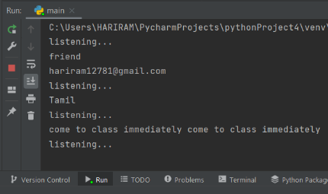

Fig. 3. Output of Email voice assistant

In Figure 3, Depiction of email voice assistant has been shown. This program has the command for importing the SMTP library at the first, then for speech recognition and pyttsx3. Then we created a server SMTP which has smtp.gmail.com and a port of 587. Then provide email id and password for authentication. Then provide the list of email id’s “to whom you want to send email”. Then type code for installing speech recognition as sr. and also,

for microphone (listener). While giving attempt to run the program “The voice controlled assistant pays attention to user and then gets voice input of receiver, subject content and body content of the email and later sends the message”.

# V. Comparison between proposed system and existing system

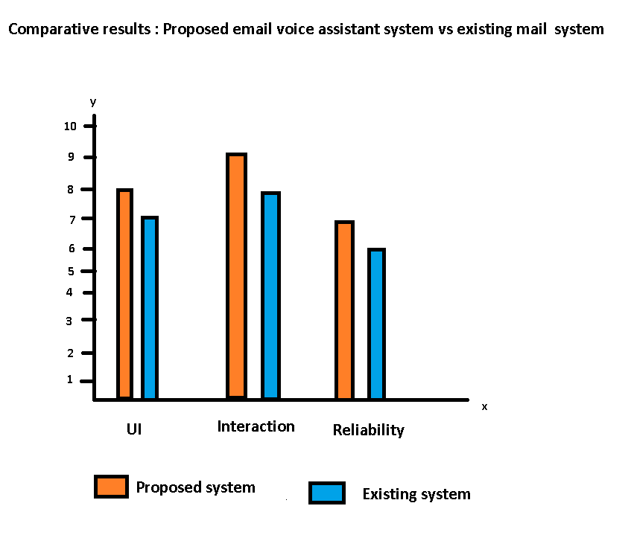

Fig .4. Relative results Proposed vs Existing system .

The relative survey of proposed email voice assistant system with existing email system is explained in the above figure 4 . Many Existing methodologies were related with this concept paper . The Proposed system works fine in terms of attributes such as User Interface, Interaction and Accuracy by comparing with the other email system specified in the literature papers[2] [5] [6]. The accuracy of existing mail system specified in the literature papers [7][8][10] are relatively lesser than the proposed system. The proposed technique make use of SMTP library and packages like pyttx3, pyaudio, speech recognition and microphone. This method will reduce the need for the manual method of typing the email to a recipient. The Proposed model assists the users (sender ) for quick and secure mail transfer facilities.

From the bar chart, the proposed system has better functionality when compared to existing system.

The constraint of the proposed system is, the sender should enable the less secure app access in their Gmail account. Also, sender should provide account credentials.

# VI. Result and discussion

The proposed model is a completely integrated AI deployed voice system with the assistance of Python. It allows the user to send email messages to a recipient through voice. The sender can interrelate with the email voice assistant and then assistant sends the information to the recipient. Figure 5 explains Use case diagram for the proposed email voice assistant model.

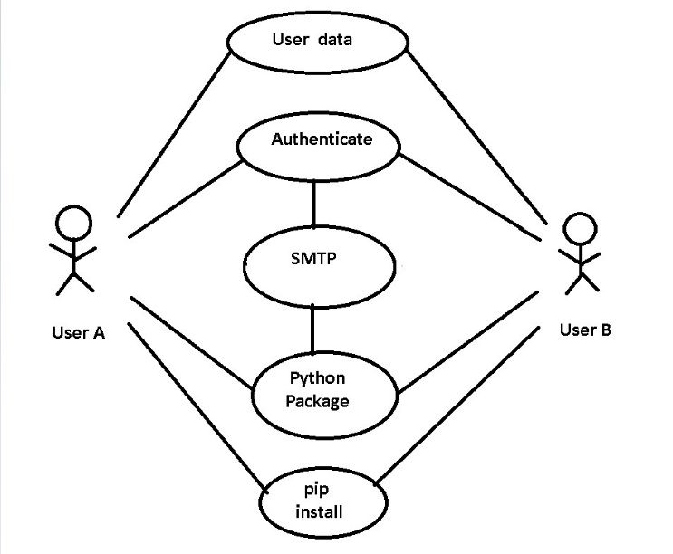

Fig.5. Use case diagram of proposed email voice assistant model.

In Fig. 5, Depiction of use case diagram of proposed email voice assistant is shown. User A (sender) has to provide his data such as email id and password. Then, his data is authenticated. Then, smtplib has to be imported. Then, he have to install python packages such as pyttsx3, speechrecognition, PyAudio and microphone. He have to install all these packages through pip( Preferred Installer Program).

Compare to the other email models, the proposed model shows an edge over the existing system by giving voice commands to the email assistant .

The sender’s option is not restricted to one recipient also more recipients can be added in the surrounding code space.

# VII. Conclusion

We suggested a systematic solution to provide email voice assistant with Python. There are three modules in this model which are login access, importing libraries &installing packages and giving voice commands. The sender should feel comfort to send mail to any recipient through this mail assistant.

We have terminated the conception of keyboard shortcut usage, for decreasing logical load of recollecting shortcuts of keyboard. Any user who has lack of experience on systems and who doesn’t know the exact position of keys on keyboard need not to bother as utility of keyboard is terminated. This paper is designed for enhancing the use of voice assistant in Gmail . The concept model can be further improved to suggest more convenient interface and more security, in future improvement.

Conversational Artificial Intelligence technique is used to improve this paper. This paper is not only for the normal people also visually challenged people can access this email system as it uses our voice only .AI will be cheaper allowing the existing mail system to be replaced by various effective results in future.

This concept is totally based on interactive speech reply which makes it to feel efficient and convenient to use .

##### REFERENCES

[1] Harsh D Shah, Amit Sundar, Shabnam Sharma . , “Controlling Email System Using Audio with Speech Recognition and Text to Speech” , IEEE 9th International Conference on Reliability, Infocom Technologies and Optimization ( Trends and Future Directions) (ICRITO), 2021.

[2] Sunny Kumar , Yogitha R. , R. Aishwarya . , “Voice Email Based on SMTP For Physically Handicapped” , IEEE 5th International Conference on Intelligent Computing and Control Systems (ICICCS) , 2021.

[3] Suresh Malodia , Nazrul Islam , Puneet Kaur , Amandeep Dhir . , “Why Do People Use Artificial Intelligence (AI) - Enabled Voice Assistants ?” , IEEE Transactions on Engineering Management , 2021.

[4] S. Subhash, Prajwal N Srivatsa, S . Siddhesh, A . Ullas, B . Santhosh. , “Artificial Intelligence – based Voice Assistant”, IEEE , 2020.

[5] Sherly Noel . , “Human Computer interaction ( HCI ) based Smart Voice Email ( Vmail ) Application–Assistant for Visually Impaired Users ( VIU )” , IEEE , 2020.

[6] Tae - Kook Kim . , “Short Research on Voice Control System Based on Artificial Intelligence Assistant” , IEEE 2020 International Conference on Electronics Information, and Communication (ICEIC), 2020.

[7] Georgios Germanos, Dimitris Kavellieros, Nicholas Kolokotonis, Nikolas Georgiou . , “Privacy Issues in Voice Assistant Ecosystems”, IEEE 2020 IEEE World Congress on Services (SERVICES), 2020.

[8] Dengke Tang , Juplin Zeng , Ming Li., “An End-to-end Deep Learning Framework for Speech Emotion of Atypical Individuals”, Interspeech , pp; 162 – 166, 2018.

[9] Saadman Shahid Chowdary , Atiar Talukdar, Ashik Mahmud , Tanzilur Rahman. , “Domain Specific Intelligent Personal Assistant with Bilingual Voice Command Processing” , IEEE TENCON 2018- 2018 IEEE Region 10 Conference, 2018.

[10] Prince Bose , Apurva Malpthak , Utkarsh Bansal , Ashish Harsola. , “Digital assistant for the blind” , IEEE 2nd International Conference for Convergence in Technology (I2CT), 2017.

[11] Patrik Emanuel Mezo, Mirzea Vladutiu, Lucian Prodan., “HMail: A hybrid mailing system based on the collaboration between traditional and Peer - to - Peer mailing architectures”, IEEE 2012 7th International Symposium on Applied Computational Intelligence and Informatics (SACI), 2012.